**Trial Project Report**

**Group D**

**Group Members:**

Zachary Cousins - 100827542

Tejas Patil - 100823713

Drew Gascoigne – 100827090

Abdullah Adeeb - 100833573

**Course Code: SYSC 3010**

**Date: October 2, 2013**

1. **Project Description :**

The purpose of the project is to implement a traffic light control system using the Raspberry Pi, Gertboard, and the PiFace peripheral boards. The concept is to simulate the working of a traffic light system with traffic lights controlling the north-south and the east-west flow of traffic. A pedestrian can indicate that they wish to cross the street by clicking a button. This will cause the system to eventually stop the flow of traffic in the corresponding direction and allow the pedestrian to cross. The system initially sets the Gertboard and the PiFace to detect the keys pressed. The server side implementation consists of a timer and a Java GUI. The Java GUI starts with traffic flowing in a particular direction and the lights displaying green on the Java GUI for that direction. The GUI can be seen in figure 1.1. For instance, the north-south signal is green and the road has flowing traffic, whereas, the east-west signal is red, and the cars have been stopped. At this point of time, if a pedestrian comes by and wishes to cross the street with east-west flowing traffic. He can push a button on the Gertboard, the Gertboard will then send a UDP message to the server, that a pedestrian wishes to cross the street. This will result in the east-west traffic eventually coming to a stop. This can be seen in figure 1.2 and figure 1.3. The server will then send a UDP message to the PiFace to display the LEDs with a green signal to indicate traffic to move in the north-south direction. This is the basic working of the system.

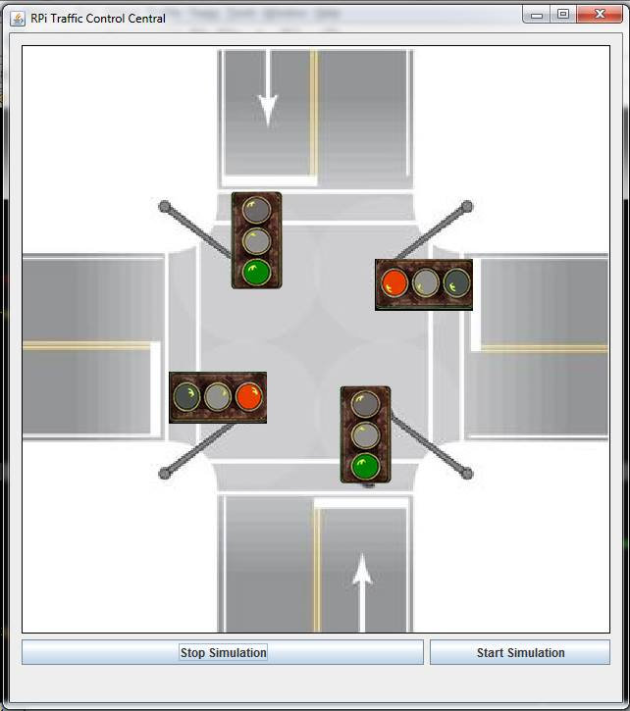

Figure 1.1: A screenshot of the GUI when the process is initialized.

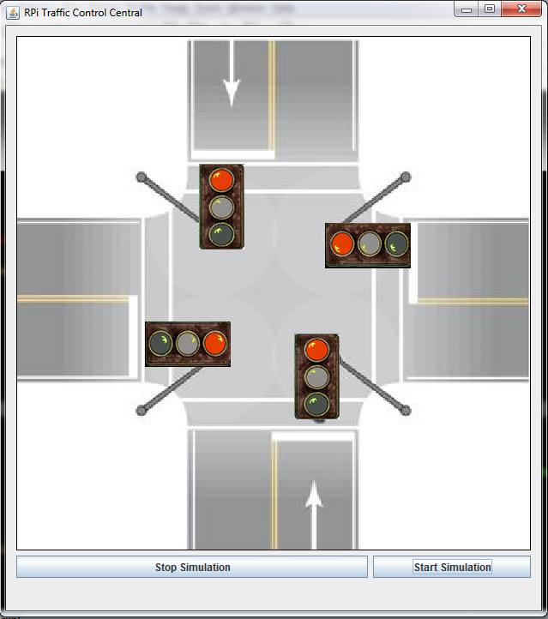

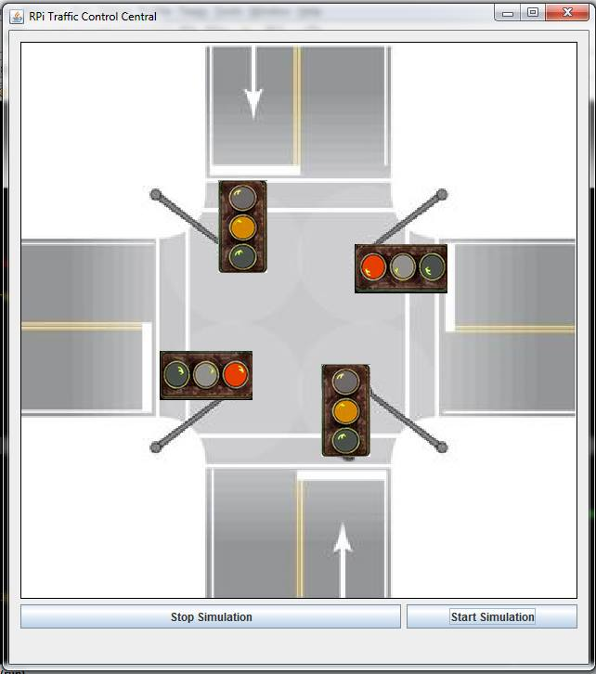 Figure 1.2: A screenshot of the GUI when a pedestrian has indicated to cross the street.

Figure 1.3: A screenshot of the GUI when the lights change direction.

**User’s perspective:**

The user sees a GUI with a “Start simulation” and a “Stop simulation” option. The “Start Simulation” will initiate the traffic flow process. While the east-west traffic controlled by the Gertboard is flowing and the traffic light is green, the PiFace which is responsible for the north-south traffic will indicate red. The colours are displayed on the GUI and the boards which allows a pedestrian to come by and click a button on either of the boards to indicate that a pedestrian wishes to cross the street. Once a button is clicked, after 1.5 seconds, the traffic flow in that direction will stop and the pedestrian can safely cross the street.

1. **High Level Design:**

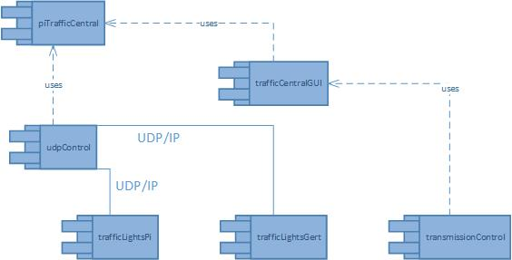

Figure 1.4: A component/deployment diagram showing the various class and their associations.

* **Hardware settings**

Connect the Gertboard and the PiFace to two separate Raspberry Pi boards. The Raspberry Pi is running similar code on both the devices. Connect the Raspberry Pi boards to the same switch via a Ethernet cable to ensure that the UDP messaging to the two boards is functioning properly.

1. **Instruction**

* **Readme.txt file is attached with the submission**